

Magnetotelluric Imaging of the Sibley Basin, Nipigon Embayment
Northern Resources Development
Earth Sciences Sector
Natural Resources Ressources naturelles
Canada Canada

Ontario Geological Survey Miscellaneous Release—Data 192
Preliminary Results of the Audiomagnetotelluric Study of the Nipigon Embayment: Lake Nipigon Region Geoscience Initiative
by J.A. Craven, S. Shareef, T.R. Hart, A. Martí and C. Farquharson

This digital data release, produced as part of the Lake Nipigon Region Geoscience Initiative (LNRGI), presents preliminary results from the largest audiomagnetotelluric (AMT) survey conducted in Ontario. The survey was successful in imaging the contact between overlying Sibley Group sedimentary rocks and underlying Archean basement, as well as imaging individual Nipigon mafic sills. The report provides a brief overview of survey methodology and the rock property characteristics that allow for resolution of specific rock units. Preliminary two-dimensional (2D) interpretations of the AMT results along 5, mainly east to west survey lines is provided in 2 portable document format (.pdf) files, one of which is adapted from a Microsoft® PowerPoint presentation presented at the December 2005 Ontario Exploration and Geoscience Symposium. In addition, a preliminary three-dimensional (3D) interpretation of an area is presented as an audiovisual format (.avi) file. This information is presented on 1 CD-ROM.

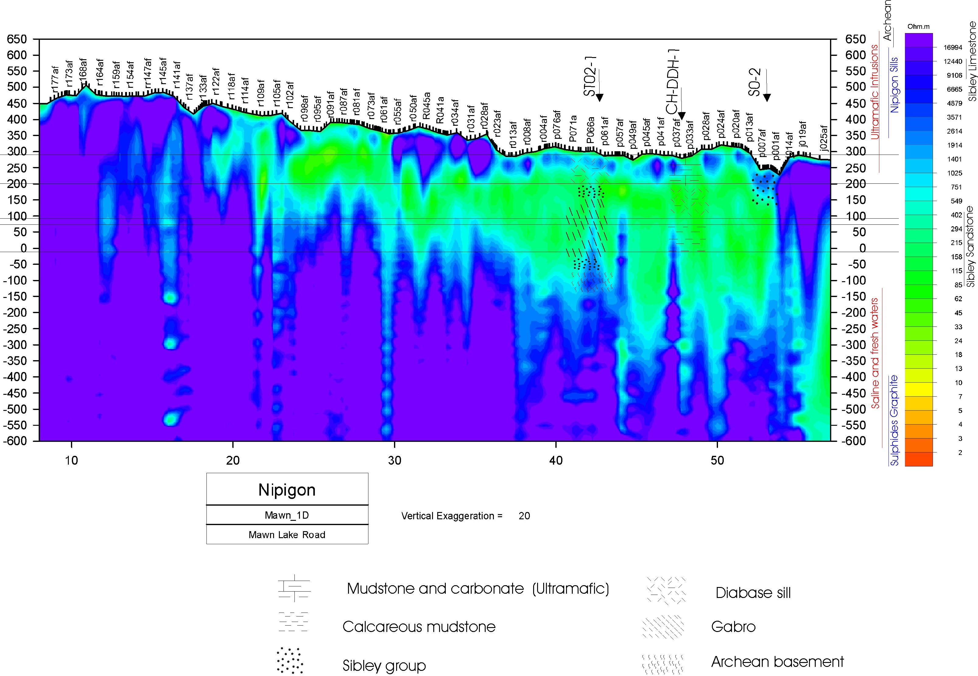
Secteur des sciences de la Terre
Ressources naturelles Natural Resources
Canada Canada
La mise en valeur
des ressources du Nord
Fact Sheet title

