Processing of 2D-3C Reflection Seismic Data
Shillington High Resolution Line
Timmins, Ontario

Peter Cary, Ph.D., P. Geoph.
Sensor Geophysical Ltd.
May, 2006

Introduction

The horizontal components of one of the eight 2D, 3C seismic lines that were part of the 204 line-km data acquisition project managed by the Timmins Economic Development Corporation (TEDC) in 2004 were processed by Sensor Geophysical Ltd. The processing produced a final seismic image which is of reasonably good data quality. An unusual method of estimating the large shear statics was crucial to the processing. This technique, as well as other aspects of the processing, are described in this report.

Acquisition and Geometry

The relatively short Shillington high resolution line, shown in Figure 1, was chosen for converted-wave (P-S) processing. Kinetex Inc. of Calgary, Alberta acquired the data with an I/O VectorSeis system. The 10 km line was recorded with a 12.5 metre receiver interval and 25 metre source interval using a Vibroseis source array. The line sweep was 28 seconds long. The sweep was non-linear, +3 dB/Octave boost, over the frequency band 10-160Hz. The listen time was 34 seconds. The correlated record length was 9 seconds.

The processing of the vertical component of all eight lines was conducted in 2004 and 2005 by Sensor Geophysical Ltd. The final migrated stack of the vertical component is shown in Figure 2.

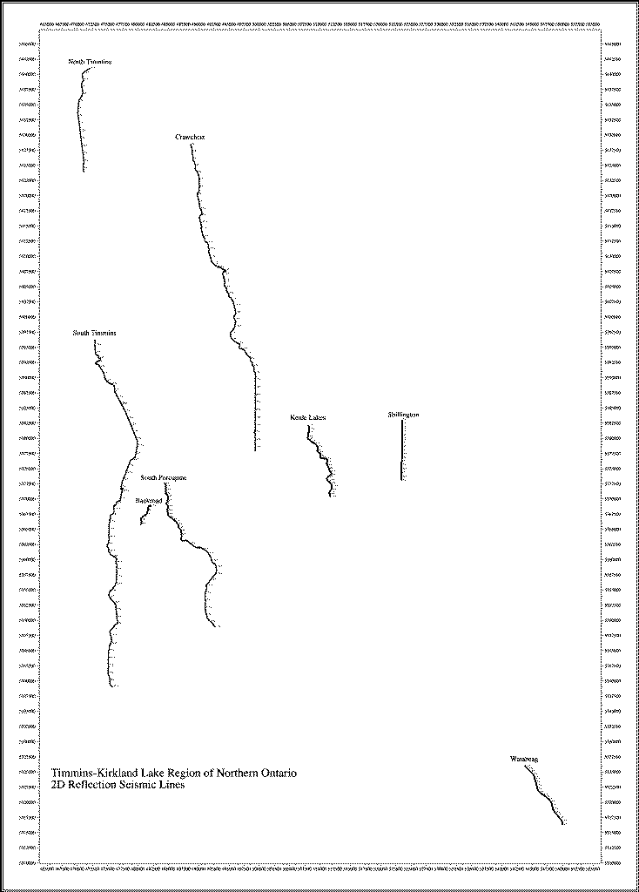

Figure 1. Sketch map showing location of Shillington 3 high resolution line based on UTM coordinates.

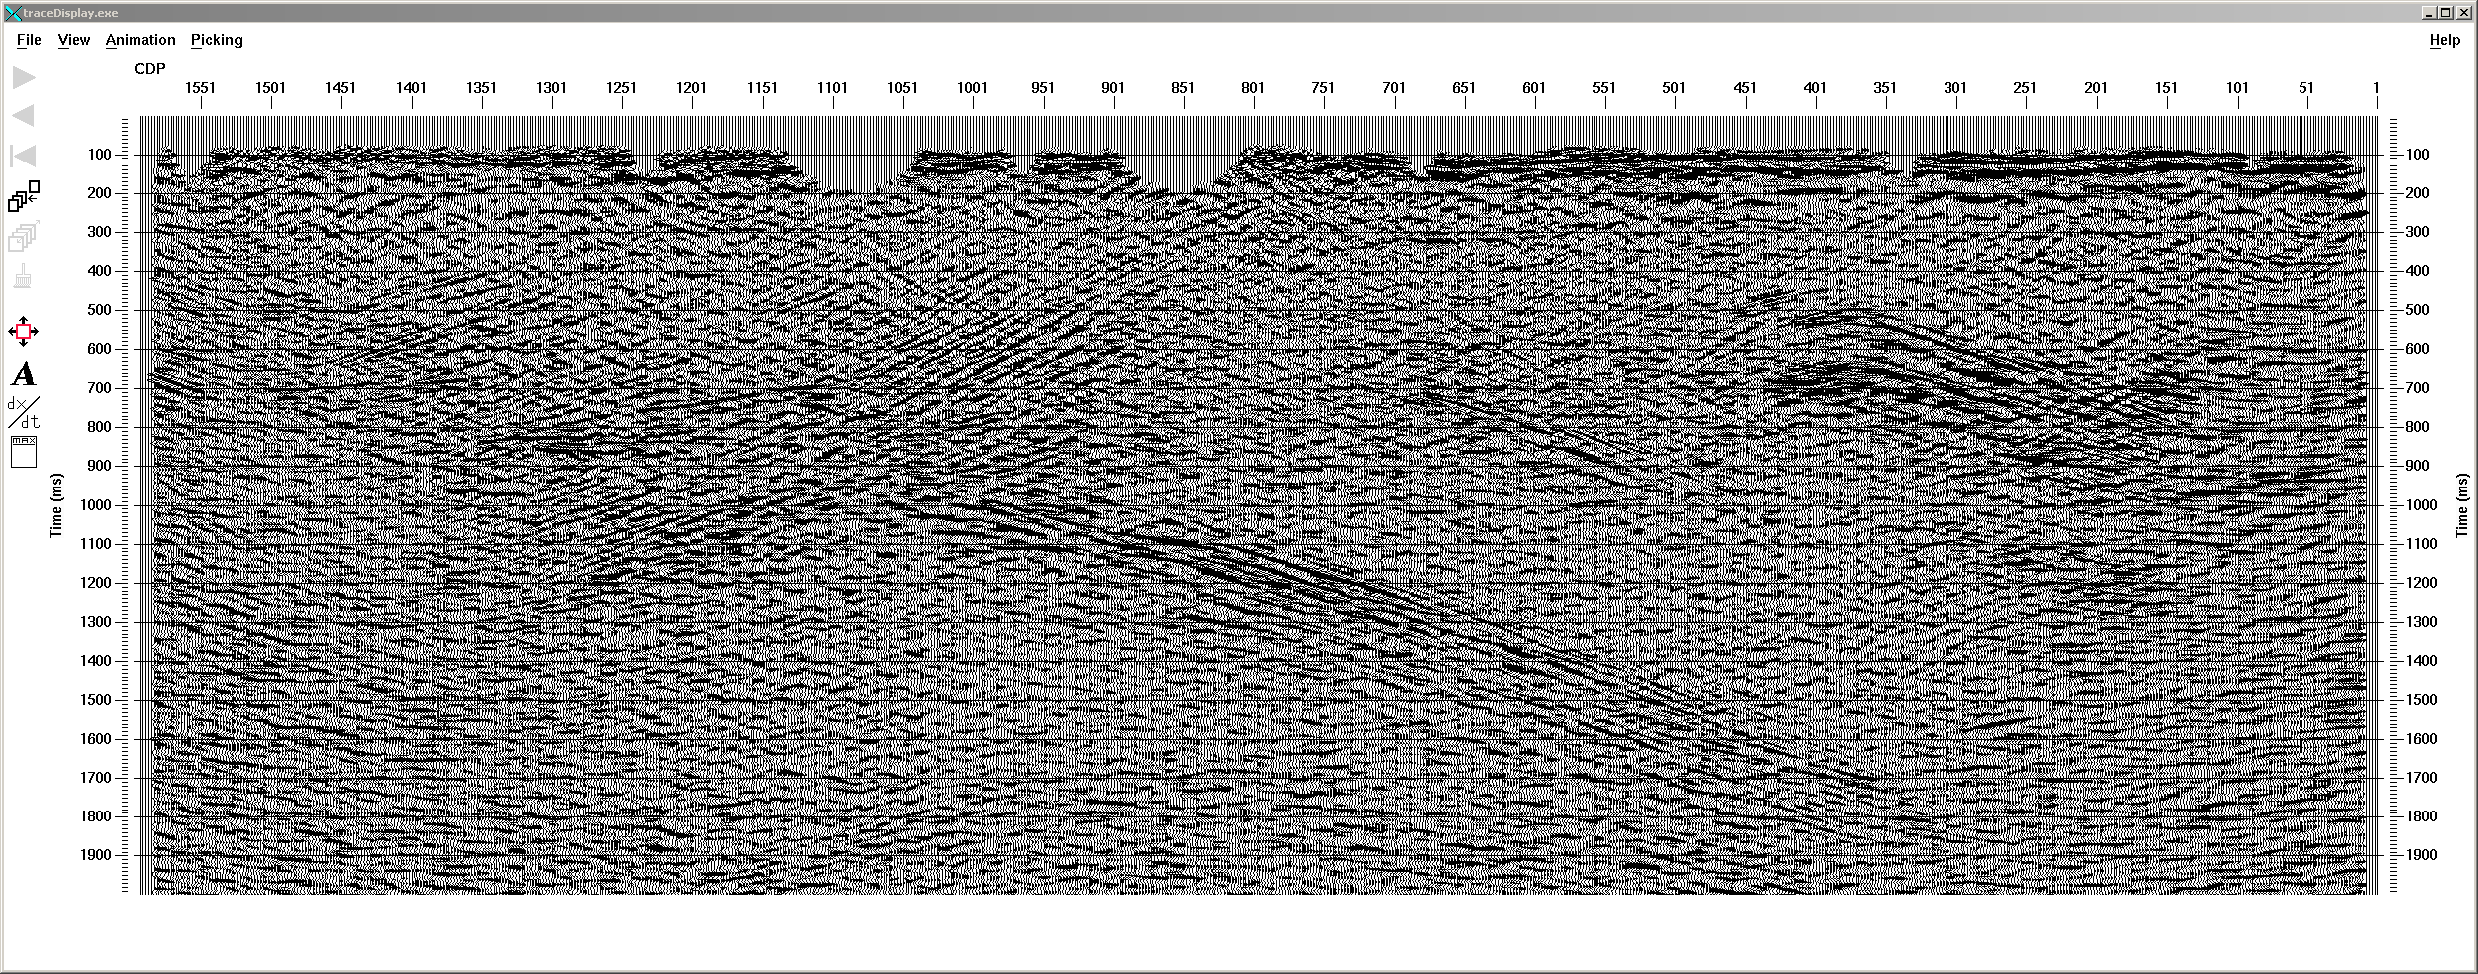

Figure 2: Migrated stack of vertical component.

Data Processing

The horizontal components were processed using a very different processing flow from that of the vertical component. The final processing flow is summarized in Table 1. The transverse component processing used the velocities and statics from the radial component.

Table 1: Radial and Transverse Component Processing Summary

. Assign geometry to inline and crossline components in exactly the same way as for the vertical component.
. Rotation from inline/crossline components to radial/transverse components. Selection of radial component for further processing.
. Asymptotic CCP binning
. Inspection of data for exclusion of noisy traces and noisy receivers.
. Amplitude recovery, spherical divergence correction 1/tv².
. Surface-consistent deconvolution
. Vibroseis deconvolution compensation
. Trace-by-trace time-variant spectral whitening.
. Application of refraction statics as determined from vertical component..
. Application of receiver-consistent statics calculated from secondary shear arrival after P-wave first break.
. Calculation and application of surface-consistent residual statics (stack-power maximization method)
. Normal moveout correct
. Trace muting
. Automatic gain control (AGC)
. Apply static to move to final datum
. Gather and partially stack data into constant-offset sections
. f-x decon noise attenuation of constant-offset sections
. AGC
. Apply static to move to floating datum
. Apply converted-wave dip moveout (P-S dmo with Vp/Vs = 1.9)
. Post-dmo trace kills at ends of constant-offset sections
. Stack constant offset-sections
. Time-variant spectral whitening
. Trace equalization
. f-x decon noise attenuation
. Implicit finite-difference time migration
. Bandpass frequency filtering
. Time-variant scaling
. Plot to paper / Output to SEG-Y file

Migrated Radial P-S Stack

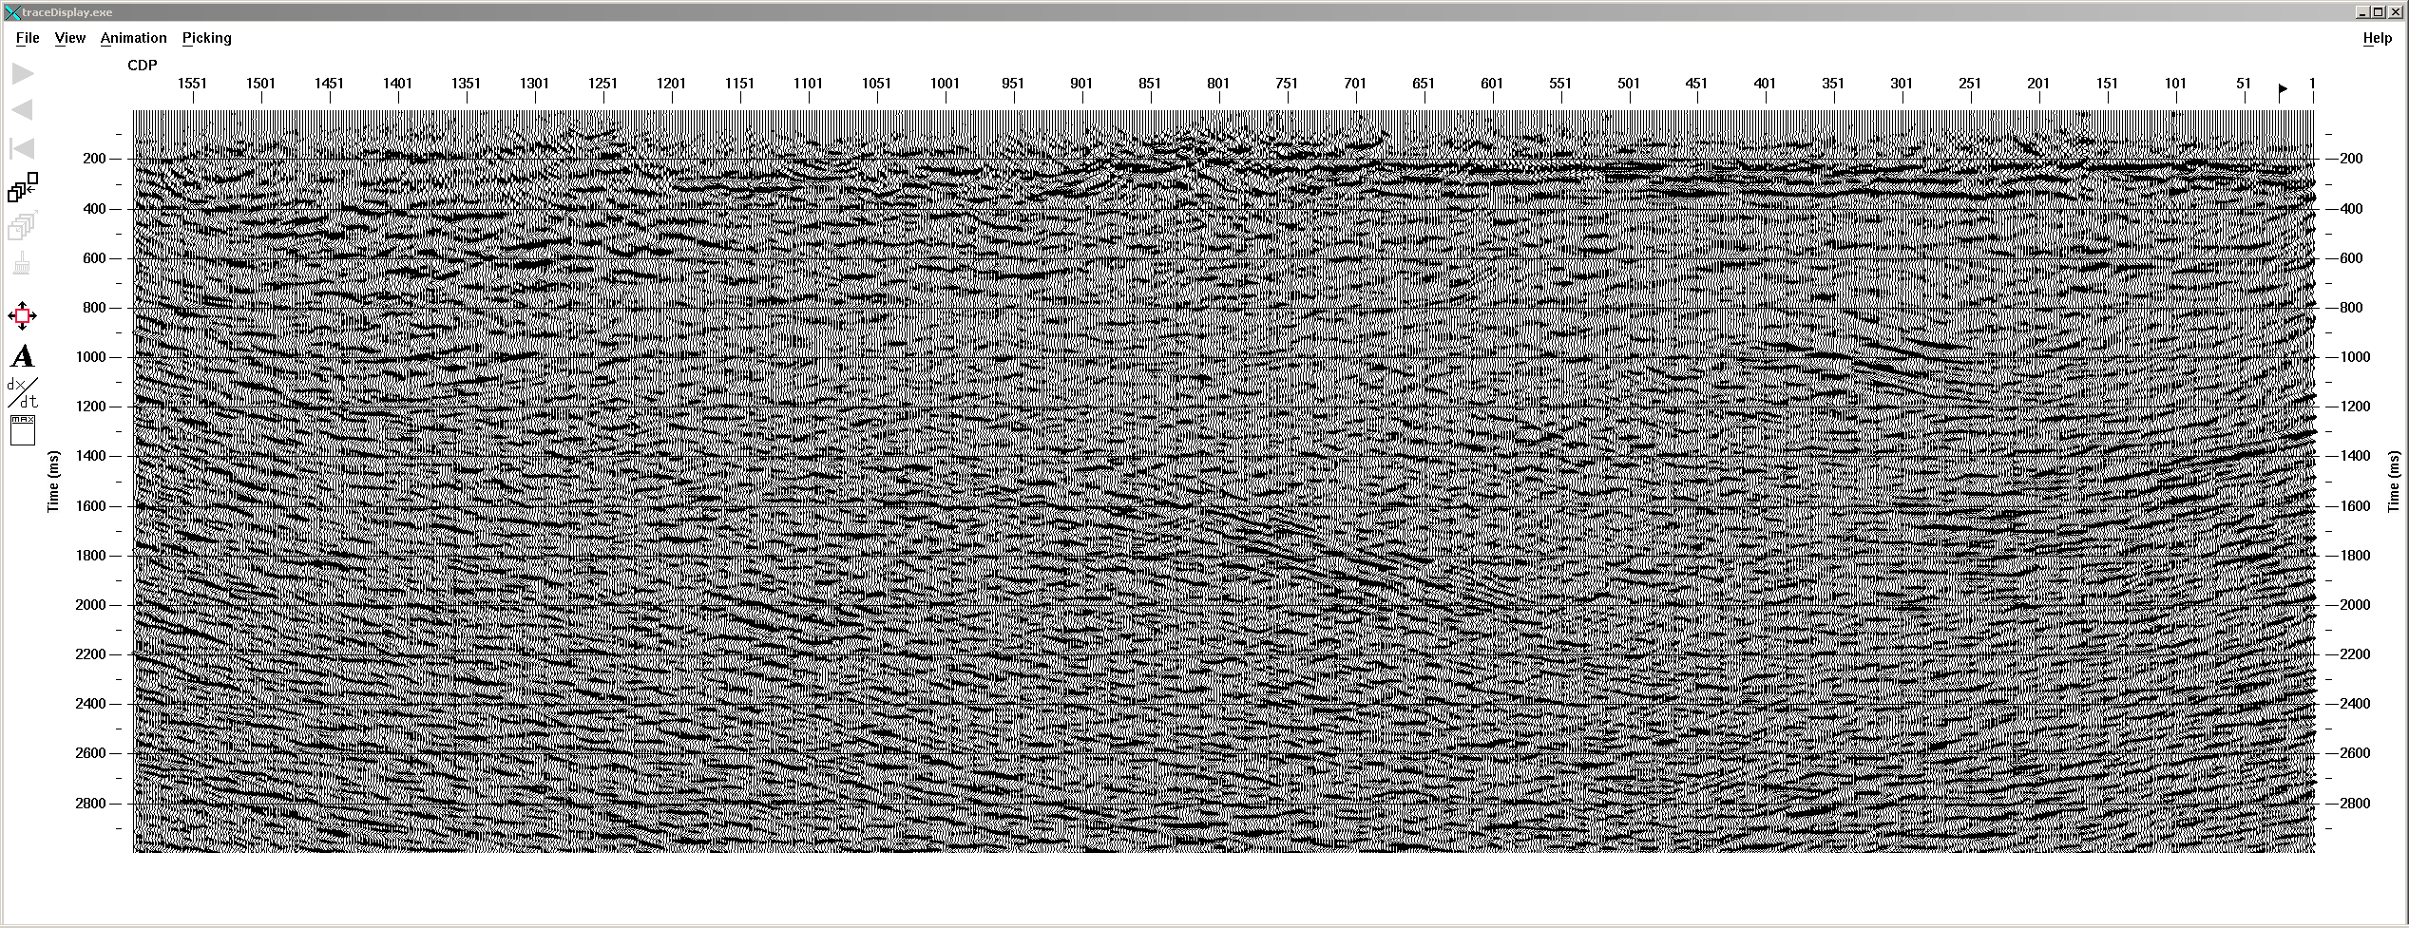

Transverse P-S Structure Stack

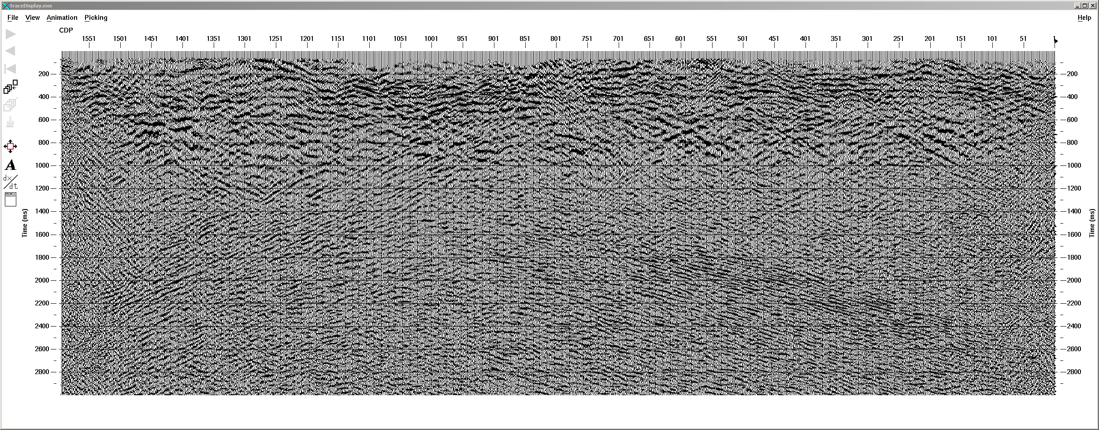
Shear-Wave Statics Estimation

The most difficult step in the processing was the estimation of the large shear statics that are consistent with each receiver position. For converted-wave data acquired in a sedimentary basin, these statics are typically on the order of +/- 50 to 100 ms. In the case of this dataset that is acquired in an unusual location, the shear statics are on the order of +/- 70ms, which is considerably larger than the dominant period of the P-S data. Without a reasonably good estimation of these statics, a coherent stack cannot be obtained.

The most commonly used method for the estimation of shear statics on P-S data is a method which relies on the existence of a suite of reflectors that exist from one end of the seismic line to the other (Cary and Eaton, 1993). This is the situation that exists in most sedimentary basins, which is where most converted-wave data is acquired. However, this is obviously not the case for this data. The volcanics do not have enough coherent reflectors for the standard method of statics estimation to be of any use. Another method that can sometimes be used depends on the existence of shear-wave refractions that are generated at or near the source (Dufour et al., 1996). This type of arrival is not observed in all datasets. Although this type of arrival is visible on this dataset, it is difficult to follow consistently from source point to source point. Picking the arrival times of the shear refraction arrival, which passes through the middle of the shot records, is a great deal of work. Fortunately another, even more unusual method of statics estimation was able to be used on this data.

At the 2002 SEG meeting, Y. Li proposed a method of converted-wave statics estimation that uses the fact that in some situations, a strong shear first arrival is visible shortly after the p-wave first arrival. This type of arrival is usually not visible, but in this case it is. This presumably has something to do with the unusually large contrast between high and low velocities of the volcanics and glacial till at the surface in the area where this data was acquired. Figure 3 shows a source record from the radial component dataset. We can see a weak first arrival followed by a much stronger secondary arrival. Figure 4 shows the corresponding vertical source record. We can see that the arrival times of the weak arrival in Figure 3 correspond to the P-wave arrival in Figure 4. We interpret the strong arrival as a refraction arrival that travels as a P-wave until it encounters the low-velocity near-surface layer below each receiver, where it converts by transmission to a shear wave. Li (2002) shows how to use the difference in the arrival time between the P-wave on the vertical component and the S-wave on the radial component to estimate the large shear statics.

I have modified Li’s method of picking the time difference between the P and S arrivals since I found that his crosscorrelation method did not allow decisive results. Instead I applied a linear moveout of 5500 m/s to each receiver record, and stacked the first arrivals from 0 to 4000 m offset in order to get a strong arrival for each receiver that is easy to pick compared to the neighbouring receivers. Figure 5 shows the radial component stack of first arrivals, and Figure 7 shows the vertical component stack of first arrivals. Figure 6 and 8 show the corresponding P and S wave first arrival picks in red. The receiver-consistent shear statics were computed from the difference between the two.
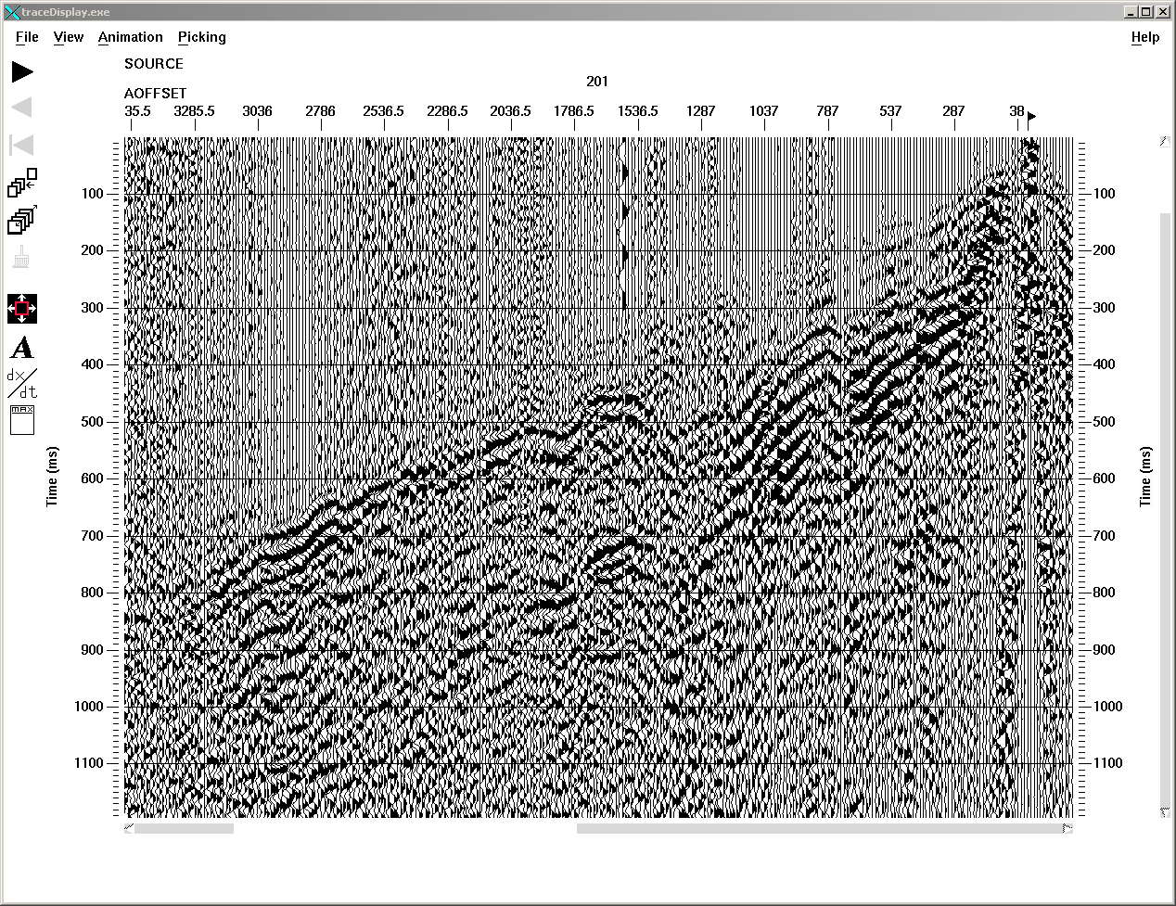
Figure 3: Radial component source gather showing strong shear first arrival after weak P-wave first arrival.

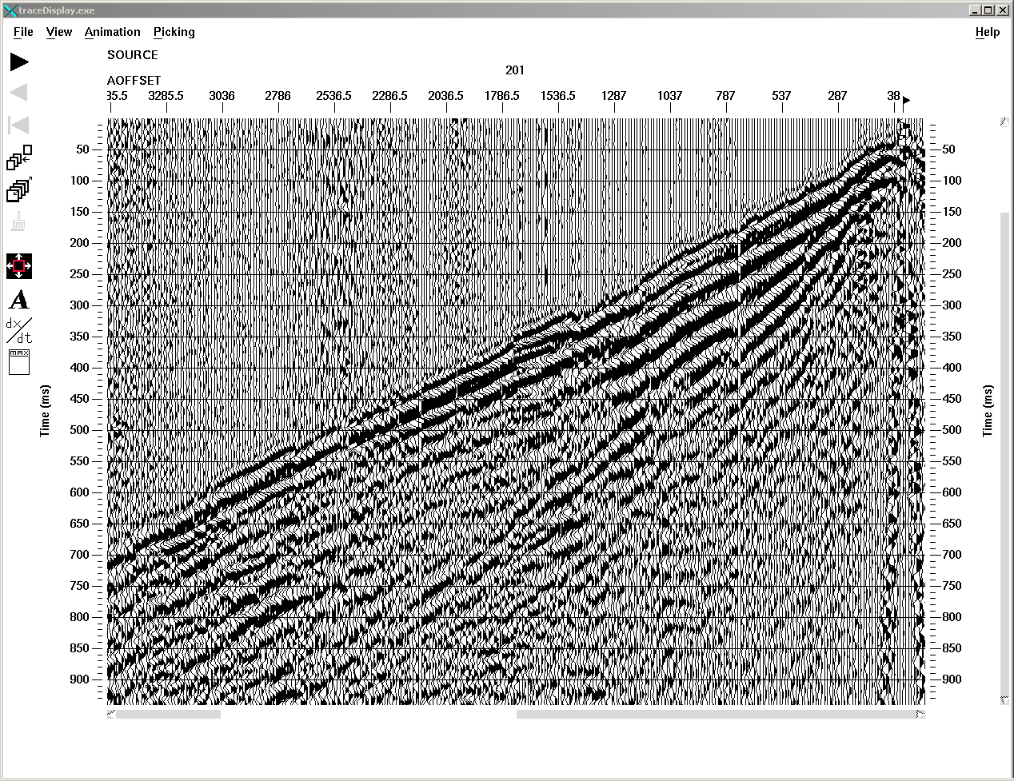
Figure 4: Vertical component source gather showing P-wave first arrival.
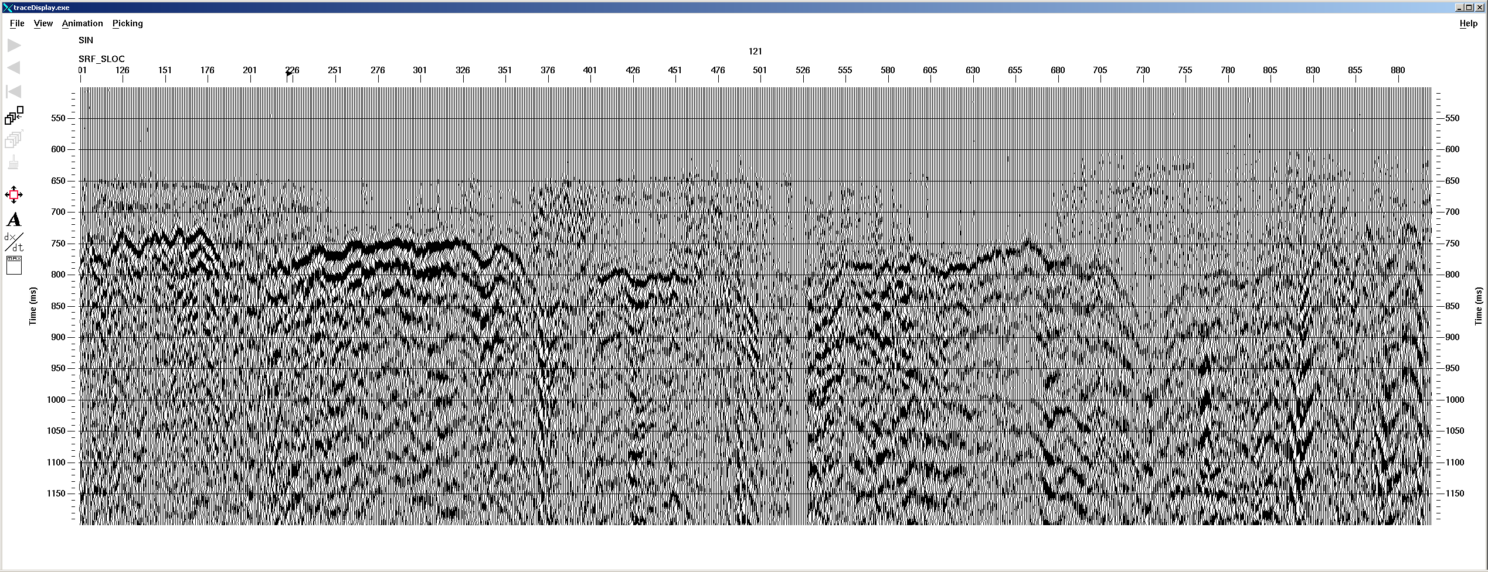
Figure 5: Radial receiver stack of first break arrival.
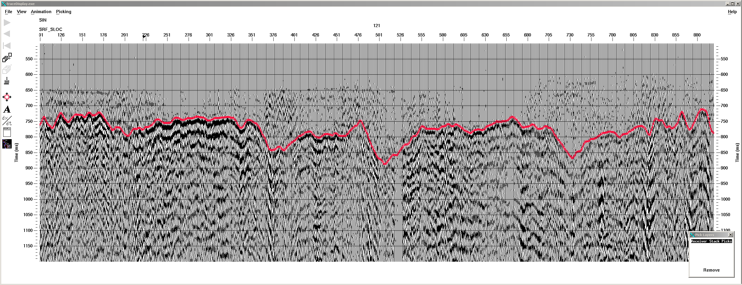
Figure 6: Same as Fig. 5. Red line shows pick of first shear arrival
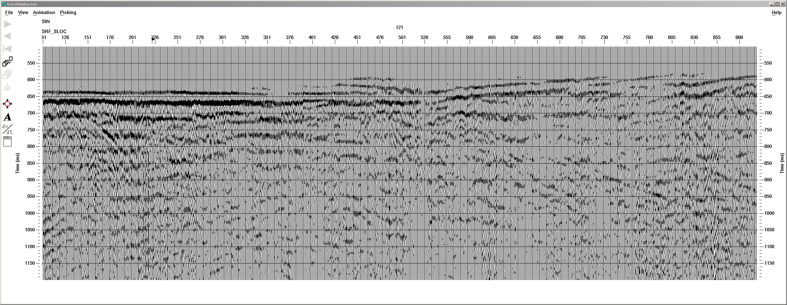
Figure 7: Vertical receiver stack of first break arrival.
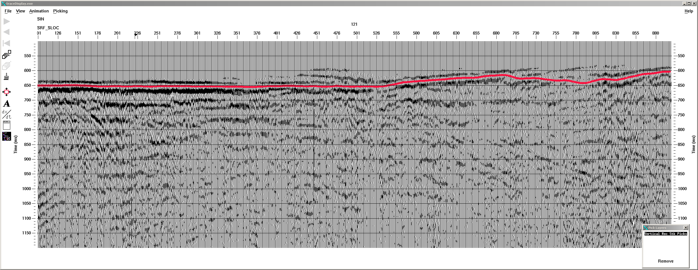
Figure 8: Same as Fig. 7. Red line shows pick of first P-wave arrival.

P-S DMO

Another important step in the processing of the P-S data was the application of P-S dip moveout (DMO). Dip moveout is a process that compensate for reflection point dispersal and remove the dip-dependence of stacking velocities. It also can have quite a profound impact as a noise attenuator, especially if the data is very noisy. Figure 9 shows the asymptotic CCP stack of the radial component with f-x noise attenuation applied. Figure 10 show the P-S DMO stack of the radial component. There is a change in the position and coherence of several of the dipping events (and even of the flat events near the surface). In addition there is a general improvement in the signal to noise ratio of the image.

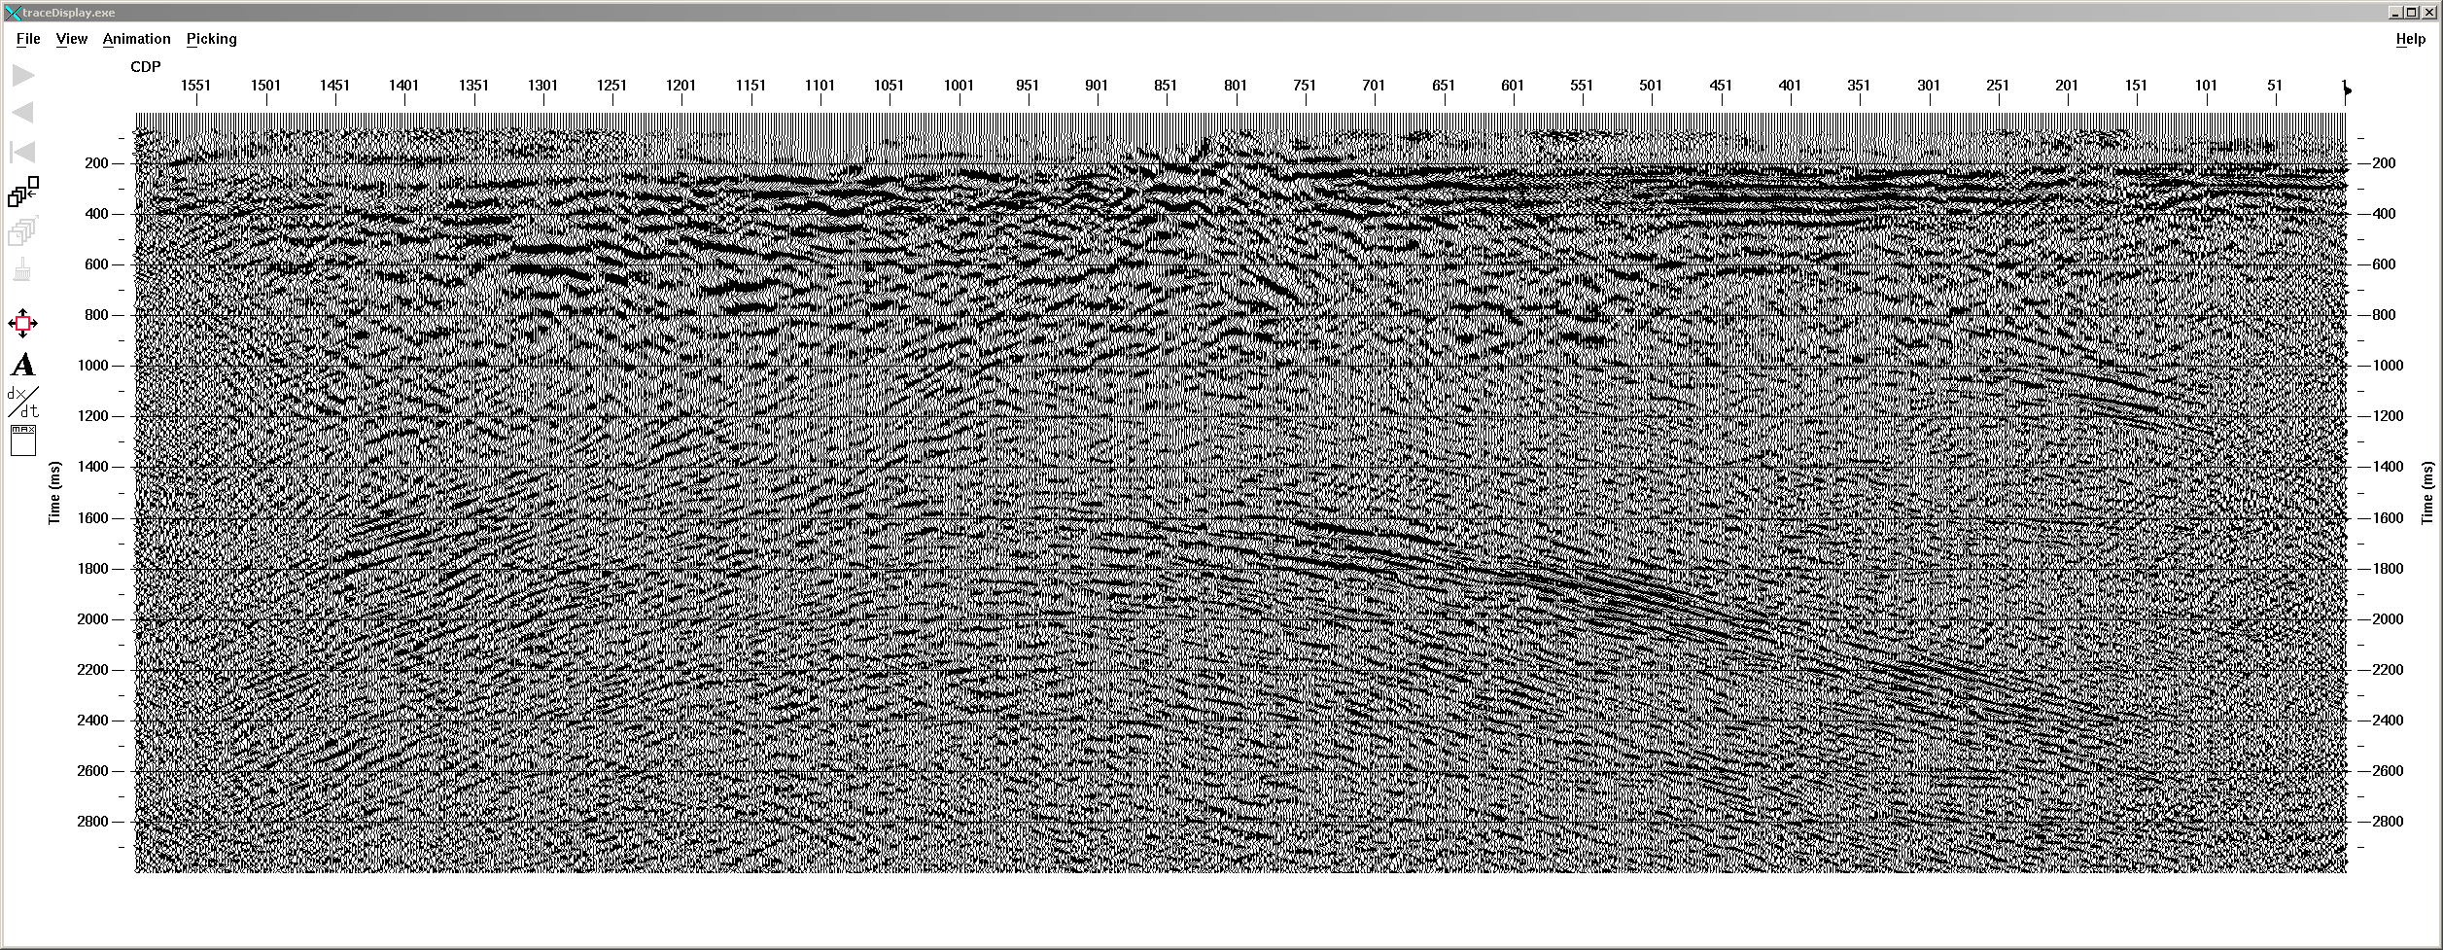
Figure 9: Asymptotic structure stack of radial component

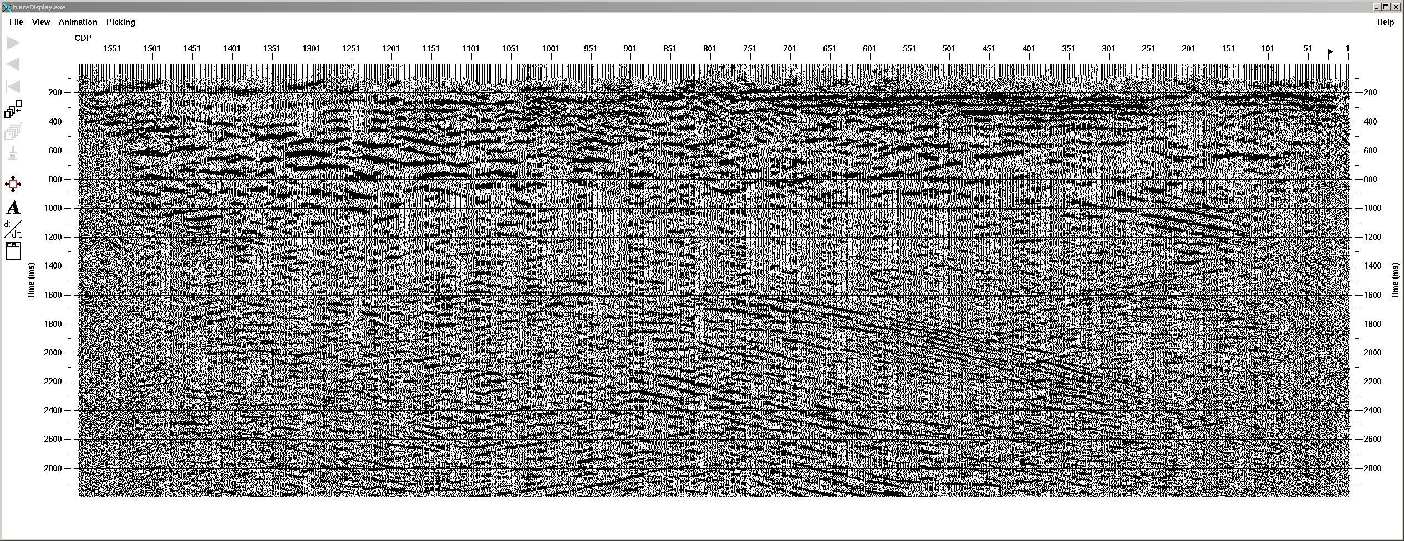
Figure 10: P-S DMO stack of radial component

Transverse component

The transverse component is perpendicular to the radial component. In a two-dimensional isotropic earth, there would be no signal on the transverse component. In practice there is always amount of coherent energy recorded on the transverse component due to shear-wave splitting and off-line scattering and reflection. For completeness, the transverse component was processed through to structure stack using the velocities and statics from the radial component. As expected, there is some coherent reflections, which could either be from shear-wave splitting or off-line reflection or both.

Final Products

. Final structure stacks and migrated structure stacks were written to DVDs in SEG-Y format.
. Raw seismic traces with geometry, crooked line binning, trace edits, and first break arrival times in trace headers were written to DVD.
. Paper plots of the final migrated stacks were made at 1:25,000 (same as for the vertical component)
. Screen captures of final images were written to a powerpoint file and sent via email.

References

Cary, P. W. and Eaton, D. W. S., 1993, A simple method for resolving large converted-wave (P-SV) statics (short note): Geophysics, Soc. of Expl. Geophys., 58, 429-433.

Dufour, J., Lawton, D. C. and Gorek, S., 1996, Determination of S-wave static corrections from S-wave refractions on P-S data, 66th Ann. Internat. Mtg: Soc. of Expl. Geophys., 1551-1554.

Li, Y., 2002, A new method for converted wave statics correction, 72nd Ann. Internat. Mtg: Soc. of Expl. Geophys., 979-981.

